**CHAPTER 1**

**INTRODUCTION**

“ONLINE VOTING SYSTEM” is an online voting technique. In this system people whose age is above 18 years of age and any sex can give his\her vote online without going to any physical polling station. There is a database which is maintained in which all the names of voters with complete information is stored.

In “ONLINE VOTING SYSTEM” a voter can use his\her voting right online without any difficulty. He\She has to be registered first for him/her to vote.

The main purpose of this study is to boost the turnout of votes. For this purpose we have to view all the aspects responsible for low turnout. Some people hesitate to vote due to weather conditions in different area during the election, youngsters of age group 18-24 having no charm to cast the vote. People who are outside of their town/city don’t want to come to their area for just casting the votes due to the expenses and trouble of transportation. Same situation is also for those who are duty during the election, they don’t have any interest to cast their vote during job or they don’t have facility to submit their vote.

A second purpose is to make it more difficult to commit fraud and cheating during an election. In a manual system, sometimes people are registered in more than one area and can thus cast the vote multiple times. By creating an online database covering the country it will be possible to eliminate the double casting of votes. In some areas, officials of the Election Commission themselves cast votes and after the end of election they adjust these votes from the voter’s list. Hence they manipulate the result of the election. There is clearly a need of a system that could reduce the authority of officials and could sustain the true nature of voting. It would also give people options to cast an empty vote if they don’t like to give the vote to any of the candidates.

**CHAPTER 2**

**REQUIREMENTS ANALYSIS**

The requirement analysis specifies the requirements needed to develop a graphic project. In this phase, we collect the requirements needed for designing the project. The requirements collected are then analyzed and carried to the next phase.

**2.1 SOFTWARE REQUIREMENTS:**

1. Operating System: Windows 10
2. Scripting Language: HTML,CSS, PHP
3. Front-end Development: HTML, CSS
4. Back-end Development: PHP & MYSQL

**2.2 HARDWARE REQUIREMENTS**

1. Processor – Intel core i5 or above
2. RAM – 2 GB or more
3. Hard disk – 3 GB or more

**CHAPTER 3**

**DESIGN**

**3.1 ER DIAGRAM**

An **Entity – Relationship model** (**ER model**) describes inter-related things of interest in a specific domain of knowledge. An ER model is composed of entity types (which classify the things of interest) and specifies relationships that can exist between instances of those entity types.

The E-R diagram of our ONLINE VOTING SYSTEM contains 6 Entities

(voter, admin, candidates, cm_vote, pm_vote,mla_vote)

In the E-R Diagram VOTER: is the entity where we can enter all the details of the voter.

ADMIN: is the entity where we can enter user name and password.

CANDIDATE: is the entity where we can enter and view the details of all the candidates

of different parties.

CM_VOTE: is the entity where admin can get the total count of votes casted to CM.

PM_VOTE: is the entity where admin can get the total count of votes casted to PM.

MLA_VOTE: is the entity where admin can get the total count of votes casted to MLA.

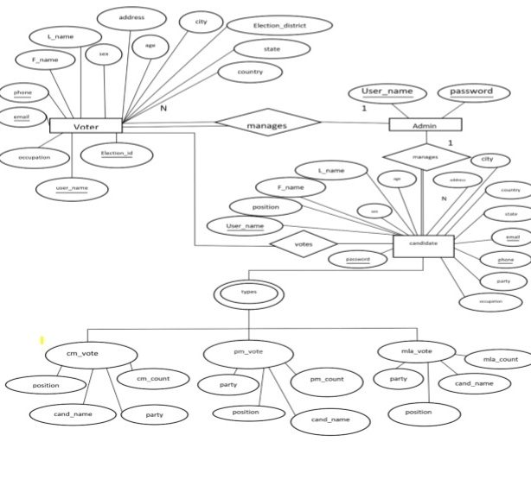

*Figure 1: Entity – Relational diagram of online voting System*

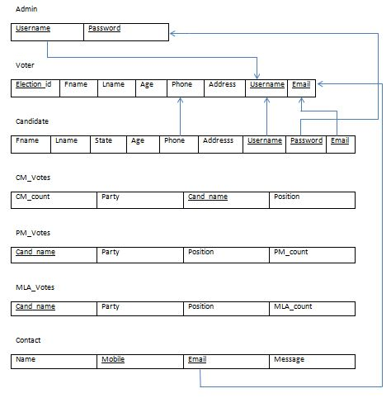

*Figure 2: Relational Schema Diagram of online voting system*

The term "**schema**" refers to the organization of data as a blueprint of how the database is constructed (divided into database tables in the case of **relational** databases).

**USECASE DIAGRAM**

The boundary, which defines the system of interest in relation to the world around it. The actors, usually individuals involved with the system defined according to their roles. The use cases, which are the specific roles played by the actors within and around the system.

ADMIN

*Figure 3: Use case diagram of ONLINE VOTING SYSTEM*

The main purpose of a use case diagram is to show who interacts with your system, and the main goals they achieve with it.

**CHAPTER 4**

**IMPLEMENTATION**

**4.1 INTRODUCTION TO FRONT END TOOL**

**4.1.1 HTML, CSS & BOOTSTRAP**

**HTML: HTML** stands for Hyper Text Markup Language. It is used to design web pages using markup language. HTML is the combination of Hypertext and Markup language. Hypertext defines the link between the web pages. Markup language is used to define the text document within tag which defines the structure of web pages. This language is used to annotate (make notes for the computer) text so that a machine can understand it and manipulate text accordingly. Most of markup (e.g. HTML) languages are human readable. Language uses tags to define what manipulation has to be done on the text.  
HTML is a markup language which is used by the browser to manipulate text, images and other content to display it in required format. HTML was created by Tim Berners-Lee in 1991. The first ever version of HTML was HTML 1.0 but the first standard version was HTML 2.0 which was published in 1999.

**CSS**: **C**ascading **S**tyle **S**heets, fondly referred to as **CSS**, is a simply designed language intended to simplify the process of making web pages presentable. CSS allows you to apply styles to web pages. More importantly, CSS enables you to do this independent of HTML that makes up each web page. CSS is easy to learn and understood but it provides powerful control over the presentation of an HTML document.

**BOOTSTRAP:** Bootstrap is a free and open source front end development framework for the creation of websites and web apps. The Bootstrap framework is built on HTML, CSS, and JavaScript (JS) to facilitate the development of responsive, mobile-first sites and apps.Responsive design makes it possible for a web page or app to detect the visitor’s screen size and orientation and automatically adapt the display accordingly; the mobile first approach assumes that smartphones, tablets and task-specific mobile apps are employees' primary tools for getting work done and addresses the requirements of those technologies in design

**4.2 INTRODUCTION TO BACK END TOOL**

**4.2.1 PHP & MYSQL**

**PHP**: The term PHP is an acronym for PHP: Hypertext Preprocessor. PHP is a server side scripting language designed specifically for web development. PHP can actually do anything related to server-side scripting or more popularly known as the backend of a website. For example, PHP can receive data from forms, generate dynamic page content, can work with databases, create sessions, send and receive cookies, send emails etc. There are also many hash functions available in PHP to encrypt user’s data that makes PHP secure and reliable to be used as a server-side scripting language.

**MYSQL**: MySQL is a Relational DataBase Management System (RDBMS).

RDBMS means R--DB--MS.

- DB stands for Database, a repository for the information store.

1. The data in a database is organized into tables, and each table is organized into rows and columns.
2. Each row in a table is called a record. A record may contains several pieces (called fields) of information, and each column in a table is known as a field.

-MS stands for Management System, the software that allows you to insert, retrieve, modify, or delete records.

-R stands for Relational, indicates a particular kind of DBMS that is good at relating information stored in one table to information stored in another table by looking for elements common to each of them. Relational DBMS has the advantage of efficient storage, and retrieval mechanisms for data, and uses normalization process during design of RDBMS. Database normalization process is beyond the scope of this article, and several references are available.

MySQL operates using client/server architecture in which the server runs on the machine containing the databases and clients connect to the server over a network. The server operating systems is usually a Linux (like Redhat 9.0 etc.) or Windows 2000 operating system. Typically mySQL is supported on Windows XP, Windows Server 2003, Red Hat Fedora Linux, and Debian Linux, and others. As with any other client/server application, MySQL is a multi-user database system, meaning several users can access the database simultaneously. Here:

-The server (MySQL server) listens for client requests coming in over the network and accesses database contents according to those requests and provides that to the clients.

- Clients are programs that connect to the database server and issue queries in a pre-specified format. MySQL is compatible with the standards based SQL (SQL stands for Structured Query Language) language. The client program may contact the server programmatically (meaning a program call the server during execution) or manually. For example, when you are issuing commands over a telnet session to a MySQL server, you are issuing the requests to the server by typing commands at your command prompt manually. On the other hand, if you have input some data (say your credit card information on the Internet towards purchase of some goods) in a form, and the form is processed by using a server side program, then the MySQL server is contacted programmatically. This is often the case in credit card approvals, member subscriptions etc.

* 1. **CONNECTIVITY OF THE DATABASE**

**There are three ways of working with MySQl and PHP**

1. MySQLi (object-oriented)
2. MySQLi (procedural)
3. PDO

**Connecting to MySQL database using PHP**

1. **Using MySQLi object-oriented procedure**: We can use the MySQLi object-oriented procedure to establish a connection to MySQL database from a PHP script.

**Syntax**:

<?php

$servername = "localhost";

$username = "root";

$password = "";

$conn = mysqli_connect($servername , $username , $password,"test") or die("unable to connect to host");

?>

**Output:**  
https://media.geeksforgeeks.org/wp-content/uploads/Screen-Shot-2017-11-20-at-2.23.19-PM.png

**Explanation**: We can create an instance of the mysqli class providing all the necessary details required to establish the connection such as host, username, password etc. If the instance is created successfully then the connection is successful otherwise there is some error in establishing connection.

**4.4 MODULES**

**Administrator login**

<?php

include('includes/conn.php');

$collect='';

if($_POST){

$collect = login($_POST);

if($collect == 'you have successfully login'){

header("location:admin_home.php");

exit;}

}

?>

<!DOCTYPE html PUBLIC "-//W3C//DTD XHTML 1.0 Strict//EN" "http://www.w3.org/TR/xhtml1/DTD/xhtml1-strict.dtd">

<html xmlns="http://www.w3.org/1999/xhtml">

<head>

<meta http-equiv="content-type" content="text/html; charset=utf-8" />

<title>|| E-VOTING ||</title>

<meta name="keywords" content="" />

<meta name="description" content="" />

<link href="default.css" rel="stylesheet" type="text/css" />

<style type="text/css">

<!--

.style1 {

color: #000000;

font-weight: bold;

font-size: 16px;

}

.style7 {font-size: 16px; font-weight: bold; }

.style8 {color: #000000; font-weight: bold; font-size: 18px; }

.style3 { color: #FF0000;

font-weight: bold;

}

-->

</style>

</head>

<body>

<div id="header">

<table width="200" align="center">

<tr>

<img src="images/logo.png" id="logo"/>

<img src="images/banner.png" id="banner" /></tr>

</table>

</div>

<div id="menu">

<ul>

<li> <a href="index.php"> | Home |</a></li>

<li> <a href="result.php">| Result |</a></li>

<li>

<a href="login.php" >| Admin Login |</a></li>

<li>

<a href="contact.php">| Contact Us |</a></li>

</ul>

</div>

<div id="content">

<div id="left">

<p style="text-align:center; color:#FF0000;"><strong><marquee behavior="scroll">

THIS E-VOTING SYSTEMIS FOR ELEGIBLE WHO ARE ABOVE 18 YEARS

OF AGE AS FROM 23RD MAY 2018

</marquee></strong></p>

</div>

<th height="41" colspan="2" scope="col"><h1><center>

</center>

</h1></th>

</div>

</div>

<div id="footer">

<p class="style8">ADMIN LOGIN</p>

<table width="371" height="177" border="1" align="center" bgcolor="#99CCFF">

<tr>

<td width="361" height="32"><table width="200" align="center" bgcolor="#CCCCCC">

<tr>

<td height="29"><div align="center"><span class="style3">ADMIN LOGIN</span></div></td>

</tr>

</table></td>

</tr>

<tr>

<td height="130"><form id="form1" method="post" action="">

<table width="313" align="center">

<tr>

<td width="96"><span class="style3">USERNAME</span></td>

<td width="205"><label>

<input type="text" name="txtusername" />

</label></td>

</tr>

<tr>

<td height="30"><span class="style3">PASSWORD</span></td>

<td><input type="password" name="txtpassword" /></td>

</tr>

<tr>

<td height="41"><label>

<input type="submit" name="Submit" value="Submit" />

</label></td> <td><input type="reset" name="Submit2" value="Reset" /></td>

</tr>

</table>

</form></td>

</tr>

</table>

</form>

<p>&nbsp;</p>

<p>&nbsp;</p>

<!--<div style="background:black;height:150px;width:770px;">

<p style="text-align:center;margin-bottom:30px;font-family:French Script MT;color:#008080;padding:20px;font-size:25px;">Project Developed and Designed<br/>By<br/>Mohandeep Bawa & Paramjeet Kaur Student of Rayat Bahra Campus, Patiala</p>-->

</div>

</div>

</body>

</html>

**Manipulation Details**

Many details such as student, company, placed student details, interview, criteria and coordinator details can manipulated by using insert, update and delete queries. The code below is a sneak peak into the execution of queries.

**1.Insertion details:-**

<?php

include('includes/config.php');

$collect='';

if($_POST){

$collect = insert($_POST);

}

?>

<!DOCTYPE html PUBLIC "-//W3C//DTD XHTML 1.0 Strict//EN" "http://www.w3.org/TR/xhtml1/DTD/xhtml1-strict.dtd">

<html xmlns="http://www.w3.org/1999/xhtml">

<head>

<meta http-equiv="content-type" content="text/html; charset=utf-8" />

<title>|| E-VOTING ||</title>

<meta name="keywords" content="" />

<meta name="description" content="" />

<link href="default.css" rel="stylesheet" type="text/css" />

<style type="text/css">

<!--

.style11 {font-size: 18px; font-weight: bold; }

.style13 {font-size: x-large; font-weight: bold; color: #000000; }

.style2 { color: #FF00FF;

font-weight: bold;

}

.style3 {

font-size: 18px;

color: #000000;

}

.style4 {font-size: 18px; color: #FFFFFF; }

.style5 {font-size: 12px}

-->

</style>

</head>

<body>

<div id="header">

<table width="200" align="center">

<tr>

<img src="images/logo.png" id="logo"/>

<img src="images/banner.png" id="banner" /></tr>

</table>

</div>

<div id="menu">

<ul>

<li> <a href="index.php"> | Home |</a></li>

<li>

<a href="login.php">| Voting |</a></li>

<li>

<a href="result.php">| Result |</a></li>

<li>

<a href="login.php" >| Login |</a></li>

<li>

<a href="contact.php">| Contact Us |</a></li>

<li>

<a href="about.php">| About Us |</a></li>

<li>

<a href="help.php">| Help |</a></li>

</ul>

</div>

<div id="content">

<div id="left">

<p style="text-align:center; color:#FF0000;"><strong><marquee behavior="scroll">THIS REISTRATION FORM IS FOR ELEGIBLE WHO ARE ABOVE 18 YEARS OF AGE AS FROM 23RD MAY 2018 </marquee></strong></p>

</div>

<th height="41" colspan="2" scope="col"><h1><center>

</center>

</h1></th>

</div>

</div>

<div id="footer">

<table width="651" border="0" align="center">

<tr>

<th width="645" height="783" scope="col"><table width="667" height="31" border="0" align="center" style="background:#ABE;">

<tr>

<th width="607" scope="col"><div align="center"><span class="style4">REGISTRATION FORM </span></div></th>

</tr>

<tr>

<th scope="col"><div "align="center" style="background:#FF00OO" >

<h1 align="center"><strong><?php echo $collect; ?></strong></h1>

</div>&nbsp; </th>

</tr>

</table>

<form action="" method="post" enctype="multipart/form-data" id="form1">

<table width="431" border="0" align="center" cellpadding="3" cellspacing="17">

<tr>

<td width="122" scope="col"><div align="justify">FIRSTNAME</div></td>

<td width="246" scope="col"><div align="justify">

<input type="text" name="txtfirstname" />

</div></td>

</tr>

<tr>

<td><div align="justify">LASTNAME</div></td>

<td><div align="justify">

<input type="text" name="txtlastname" />

</div></td>

</tr>

<tr>

<td><div align="justify">SEX</div></td>

<td><div align="justify">

<label>

<select name="txtsex">

<option value="Female">Female</option>

<option value="Male">Male</option>

</select>

</label>

</div></td>

</tr>

<tr>

<td><div align="justify">AGE</div></td>

<td><div align="justify">

<input type="text" name="txtage" />

</div></td>

</tr>

<tr>

<td><div align="justify">ADDRESS</div></td>

<td><div align="justify">

<input type="text" name="txtaddress" />

</div></td>

</tr>

<tr>

<td><div align="justify">CITY</div></td>

<td><div align="justify">

<input type="text" name="txtcity" />

</div></td>

</tr>

<tr>

<td><div align="justify">STATE</div></td>

<td><div align="justify">

<input type="text" name="txtstate" />

</div></td>

</tr>

<tr>

<td><div align="justify">COUNTRY</div></td>

<td><div align="justify">

<input type="text" name="txtcountry" />

</div></td>

</tr>

<tr>

<td><div align="justify">PHONE</div></td>

<td><div align="justify">

<input type="text" name="txtphone" />

</div></td>

</tr>

<tr>

<td><div align="justify">E-MAIL</div></td>

<td><div align="justify">

<input type="text" name="txtemail" />

</div></td>

</tr>

<tr>

<td><div align="justify">PREFERED ELECTION DISTRICT </div></td>

<td><div align="justify">

<input type="text" name="txtelectiondist" />

</div></td>

</tr>

<tr>

<td>OCCUPATION</td>

<td><div align="justify">

<input type="text" name="txtoccupation" />

</div></td>

</tr>

<tr>

<td>USERNAME</td>

<td><input type="text" name="txtusername" /></td>

</tr>

<tr>

<td>VOTER'S ID </td>

<td><input type="text" name="txtelectionid" /></td>

</tr>

<tr>

<td><input type="submit" name="Submit" value="Registered" /></td>

<td>&nbsp;</td>

</tr>

</table>

</form></th>

</tr>

</table>

<p>&nbsp;</p>

<p>&nbsp;</p>

<!--<div style="background:black;height:150px;width:770px;">

<p style="text-align:center;margin-bottom:30px;font-family:French Script MT;color:#008080;padding:20px;font-size:25px;">Project Developed and Designed<br/>By<br/>Mohandeep Bawa & Paramjeet Kaur Student of Rayat Bahra Campus, Patiala</p>

</div>-->

</div>

</body>

</html>

**2.Updation of Details:-**

<?php

$host="localhost"; // Host name

$username="root"; // Mysql username

$password=""; // Mysql password

$db_name="evoting"; // Database name

//anpp

if(isset($_POST['Submit'])) {

// Connect to server and select databse.

mysql_connect("$host", "$username", "$password")or die("cannot connect");

mysql_select_db("$db_name")or die("cannot select DB");

//$e_id ="inec/ 396" ;

//$attempt = "1";

//$pres_result = mysql_query("SELECT pres_attempts FROM attempts where election_id ='$e_id'");

//while($pres_row = mysql_fetch_row($pres_result)){

//$pres_attempt = $pres_row ['pres_attempts'];

// if ($pres_attempt >= 1){

//header("location:error.php");

$names= 0;

$result = mysql_query("SELECT pm_count FROM pm_votes where party ='BJP'");

while($row = mysql_fetch_row($result)){

$names = $row [0];

$names = $names + 1;

mysql_query("UPDATE pm_votes SET pm_count=$names WHERE party ='BJP' ");

//mysql_query("UPDATE attempts SET pres_attempts = '$attempt' WHERE election_id ='$e_id' ");

}

}

//congress

if(isset($_POST['Submit2'])) {

// Connect to server and select databse.

mysql_connect("$host", "$username", "$password")or die("cannot connect");

mysql_select_db("$db_name")or die("cannot select DB");

$names2 = 0;

//$regnum = $_POST['txtnumber'];

$result = mysql_query("SELECT pm_count FROM pm_votes where party ='CONGRESS'");

while($row = mysql_fetch_row($result)){

// $names = $row[1];

$names2 = $row [0];

$names2 = $names2 + 1;

mysql_query("UPDATE pm_votes SET pm_count=$names2 WHERE party ='CONGRESS' ");

}

}

//acn

if(isset($_POST['Submit3'])) {

// Connect to server and select databse.

mysql_connect("$host", "$username", "$password")or die("cannot connect");

mysql_select_db("$db_name")or die("cannot select DB");

$names3 = 0;

//$regnum = $_POST['txtnumber'];

$result = mysql_query("SELECT pm_count FROM pm_votes where party ='AAP'");

while($row = mysql_fetch_row($result)){

// $names = $row[1];

$names3 = $row [0];

$names3 = $names3 + 1;

mysql_query("UPDATE presidential_votes SET pm_count=$names3 WHERE party ='AAP' ");

}

}

?>

<!DOCTYPE html PUBLIC "-//W3C//DTD XHTML 1.0 Strict//EN" "http://www.w3.org/TR/xhtml1/DTD/xhtml1-strict.dtd">

<html xmlns="http://www.w3.org/1999/xhtml">

<head>

<meta http-equiv="content-type" content="text/html; charset=utf-8" />

<title>|| E-VOTING ||</title>

<script type="text/javascript">

function confirm_vote(textfield){

if(confirm("ARE U SURE YOU WISH TO VOTE FOR "+textfield+" ?"))

{

return true;

}

else {return false;

}

}

function error($msg){

if(confirm("double voting "+$msg+" ?"))

{

return true;

}

else {return false;

}

}

</script>

<meta name="keywords" content="" />

<meta name="description" content="" />

<link href="default.css" rel="stylesheet" type="text/css" />

<style type="text/css">

<!--

.style11 {font-size: 18px; font-weight: bold; }

.style13 {font-size: x-large; font-weight: bold; color: #000000; }

.style2 { color: #FF00FF;

font-weight: bold;

}

.style3 {

font-size: 18px;

color: #000000;

}

.style4 {font-size: 18px; color: #FFFFFF; }

.style5 {font-size: 12px}

.style8 {color: #990000}

-->

</style>

</head>

<body>

<div id="header">

<table width="200" align="center">

<tr>

<img src="images/logo.png" id="logo"/>

<img src="images/banner.png" id="banner" /></tr>

</table>

</div>

<div id="menu">

<ul>

<li> <a href="index.php"> | Home |</a></li>

<li>

<a href="login.php">| Voting |</a></li>

<li>

<a href="result.php">| Result |</a></li>

<li>

<a href="login.php" >| Login |</a></li>

<li>

<a href="contact.php">| Contact Us |</a></li>

<li>

<a href="about.php">| About Us |</a></li>

<li>

<a href="help.php">| Help |</a></li>

</ul>

</div>

<div id="content">

<div id="left">

<p style="text-align:center; color:#FF0000;"><strong><marquee behavior="scroll">

THIS VOTING SYSTEM IS FOR ELEGIBLE WHO ARE ABOVE 18 YEARS OF AGE AS FROM 23RD MAY 2018

</marquee></strong></p>

</div>

<th height="41" colspan="2" scope="col"><h1><center>

</center>

</h1>

</th>

</div>

<div id="footer">

<p><a href="logout.php">LOGOUT</a></p>

<table width="719" border="0" align="center">

<tr>

<th width="713" height="661" scope="col"><form id="form1" method="post" action="">

<table width="671" border="0" align="center">

<tr>

<th width="233" bgcolor="#00FF66" scope="col"><span class="style8">CANDIDATE</span></th>

<th width="197" bgcolor="#00FF66" scope="col"><span class="style8">NAME</span></th>

<th width="149" bgcolor="#00FF66" scope="col"><span class="style8">PARTY</span></th>

<th width="74" bgcolor="#00FF66" scope="col" class="style8">UPDATED RESULT </th>

</tr>

<tr>

<td height="151"><img src="images/modi.jpg" alt="" width="177" height="218" /></td>

<td>Narendra Modi </td>

<td><input type="submit" name="Submit" value="BJP" onclick="return confirm_vote('<?php echo "Narendra Modi "; ?>')" /></td>

<td id="display"><script>var d=<?php echo $names;?>;

document.getElementById('display').innerHTML=d;</script>&nbsp;</td>

</tr>

<tr>

<td height="150"><img src="images/rahul.jpg" alt="" width="180" height="182" /></td>

<td>Rahul Gandhi </td>

<td><input type="submit" name="Submit2" value="CONGRESS" onclick="return confirm_vote('<?php echo "Rahul Gandhi "; ?>')"/></td>

<td id="display1"><script>var d=<?php echo $names2;?>;

document.getElementById('display1').innerHTML=d;</script>&nbsp;</td>

</tr>

<tr>

<td height="105"><img src="images/arvind.jpg" alt="" width="178" height="183" /></td>

<td>Arvind Kejriwal </td>

<td><input type="submit" name="Submit3" value="AAP" onclick="return confirm_vote('<?php echo "Arvind Kejriwal "; ?>')"/></td>

<td id="display2"><script>var d=<?php echo $names3;?>;

document.getElementById('display2').innerHTML=d;</script>&nbsp;</td>

</tr>

<tr>

<td height="105">&nbsp;</td>

<td>&nbsp;</td>

<td><a href="pm_result.php">click here to view all parties result </a></td>

<td>&nbsp;</td>

</tr>

</table>

</form></th>

</tr>

<tr>

<th height="17" scope="col">&nbsp;</th>

</tr>

</table>

</form>

<p>&nbsp;</p>

<p>&nbsp;</p>

<!--<div style="background:black;height:150px;width:770px;">

<p style="text-align:center;margin-bottom:30px;font-family:French Script MT;color:#008080;padding:20px;font-size:25px;">Project Developed and Designed<br/>By<br/>Mohandeep Bawa & Paramjeet Kaur Student of Rayat Bahra Campus, Patiala</p>

</div>-->

</div>

</body>

</html>

**3.Deletion of Details:-**

<?php

// Check if session is not registered , redirect back to main page.

// Put this code in first line of web page.

session_start();

if( isset($_SESSION['txtusername']) ){

header("location:login.php");

}

?>

<?php

include('includes/conn.php');

?>

<!DOCTYPE html PUBLIC "-//W3C//DTD XHTML 1.0 Strict//EN" "http://www.w3.org/TR/xhtml1/DTD/xhtml1-strict.dtd">

<html xmlns="http://www.w3.org/1999/xhtml">

<head>

<meta http-equiv="content-type" content="text/html; charset=utf-8" />

<title>|| E-VOTING ||</title>

<meta name="keywords" content="" />

<meta name="description" content="" />

<link href="default.css" rel="stylesheet" type="text/css" />

<style type="text/css">

<!--

.style1 {

color: #000000;

font-weight: bold;

font-size: 16px;

}

-->

</style>

</head>

<body>

<div id="header">

<table width="200" align="center">

<tr>

<img src="images/logo.png" id="logo"/>

<img src="images/banner.png" id="banner" /></tr>

</table>

</div>

<div id="menu">

<ul>

<li> <a href="index.php"> | Home |</a></li>

<a href="result.php">| Result |</a></li>

<li>

<a href="admin_login.php" >| Admin Login |</a></li>

<li><a href="messages.php">| Messages</a></li>

<li>

<a href="contact.php">| Contact Us |</a></li>

<li>

<a href="about.php">| About Us |</a></li>

<li>

<a href="help.php">| Help |</a></li>

</ul>

</div>

<div id="content">

<div id="left">

<p style="text-align:center; color:#FF0000;"><strong><marquee behavior="scroll">

THIS E-VOTING SYSTEMIS FOR ELEGIBLE WHO ARE ABOVE 18 YEARS OF AGE AS FROM 23RD JUNE 2012

</marquee></strong></p>

</div>

<th height="41" colspan="2" scope="col"><h1><center>

</center>

</h1></th>

</div>

</div>

<div id="footer">

<p class="style1"><a href="logout.php">LOGOUT</a></p>

<p class="style1">CANDIDATE INFORMATION </p>

<table width="743" height="93" border="1" align="center" cellpadding="7" cellspacing="0" bgcolor="#999999">

<tr>

<th width="263" height="56" scope="col" >CANDIDATE NAME </th>

<th width="215" scope="col" >PARTY</th>

<th width="215" scope="col" >POSITION</th>

</tr>

<?php

$row = get_prime_vote();

foreach($row as $col_val){

$row++;

if(($row%2)==0)$format="background-color:#cccccc";

else $format="background-color:#00FF66";

?>

<tr>

<td style="<?php echo $format; ?>"><?php echo $col_val['cand_name'] ?></td>

<td style="<?php echo $format; ?>"><?php echo $col_val['party'] ; ?></td>

<td style="<?php echo $format; ?>"><?php echo $col_val['position'] ; ?> </td>

</tr>

<?php }

?>

<?php

$row = get_cm_vote();

foreach($row as $col_val){

$row++;

if(($row%2)==0)$format="background-color:#cccccc";

else $format="background-color:#00FF66";

?>

<tr>

<td style="<?php echo $format; ?>"><?php echo $col_val['cand_name'] ?></td>

<td style="<?php echo $format; ?>"><?php echo $col_val['party'] ; ?></td>

<td style="<?php echo $format; ?>"><?php echo $col_val['position'] ; ?> </td>

</tr>

<?php }

?>

<?php

$row = get_mla_vote();

foreach($row as $col_val){

$row++;

if(($row%2)==0)$format="background-color:#cccccc";

else $format="background-color:#00FF66";

?>

<tr>

<td style="<?php echo $format; ?>"><?php echo $col_val['cand_name'] ?></td>

<td style="<?php echo $format; ?>"><?php echo $col_val['party'] ; ?></td>

<td style="<?php echo $format; ?>"><?php echo $col_val['position'] ; ?> </td>

</tr>

<?php }

?>

</table>

</div>

<p>&nbsp;</p>

<p>&nbsp;</p>

<!--<div style="background:black;height:150px;width:770px;margin-left:290px;">

<p style="text-align:center;margin-bottom:30px;font-family:French Script MT;color:#008080;padding:20px;font-size:25px;">Project Developed and Designed<br/>By<br/>Mohandeep Bawa & Paramjeet Kaur Student of Rayat Bahra Campus, Patiala</p>

</div>-->

</body>

</html>

**CHAPTER 5**

**TESTING**

**5.1 TESTING**

Testing is the process of executing a program to find the errors. A good test has the high probability of finding a yet undiscovered error. A test is vital to the success of the system. System test makes a logical assumption that if all parts of the system are correct, then goal will be successfully achieved.

* 1. **TYPES OF TESTING**

5.2.1 Module Testing.

5.2.2 Integration Testing.

**5.2.1 Module Testing**

Module testing is the testing of complete code objects as produced by the complier when built from source.

A library may be composed of a single complied object or several complied objects. There is only a slight difference between unit testing and module testing. Modules are fully formed chunks of coherent source code that can typically be tested by driving a few functions signatures with various stimuli. On the other hand, unit testing (which is considered as part of the implementation phase for this software development process) may involve testing one small part of a function that will never formally implement any function interface.

As a result of modules being more self-contained, module testing will likely require less testing infrastructure such as test harness and test stubs. The testing of modules could perhaps even be automated so that they can be included in regression test suites or a acceptance test suites.

**5.2.2 Integration Testing**

Integration testing (sometimes called integration and testing, abbreviated I&T) is the phase in [software testing](https://en.wikipedia.org/wiki/Software_testing) in which individual software modules are combined and tested as a group. It occurs after [unit testing](https://en.wikipedia.org/wiki/Unit_testing) and before [validation testing](https://en.wikipedia.org/wiki/Software_verification_and_validation). Integration testing takes as its input [modules](https://en.wikipedia.org/wiki/Module_(programming)) that have been unit tested, groups them in larger aggregates, applies tests defined in an integration [test plan](https://en.wikipedia.org/wiki/Test_plan) to those aggregates, and delivers as its output the integrated system ready for [system testing](https://en.wikipedia.org/wiki/System_testing).

|  |  |  |  |  |  |
| --- | --- | --- | --- | --- | --- |
| **Test Case Id** | **Description** | **Input Data** | **Expected Output** | **Actual Output** | **Status** |
| 1 | Admin Login Page | Username  Password | Successfully  Logged in | Successfully  Logged in | Pass |
| 2 | Voter  Registration page | Manage voter details | Direct to the voting page | Directed to the voting page | Pass |
| 4 | Candidate information page | Manage candidate details | Direct to the candidate information page | Directed to the candidate information page | Pass |
| 5 | Choose election page | Manage election  details | Direct to the choose election page | Directed to the choose election page | Pass |
| 6 | Result page | Manage count of votes details | Direct to the result page | Directed to the result page | pass |

**CHAPTER 6**

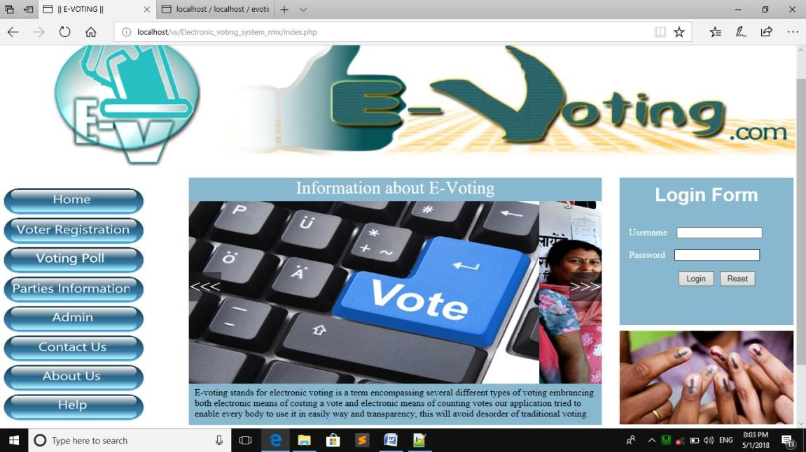 **SNAPSHOTS**

Snapshot 1:”Home page”

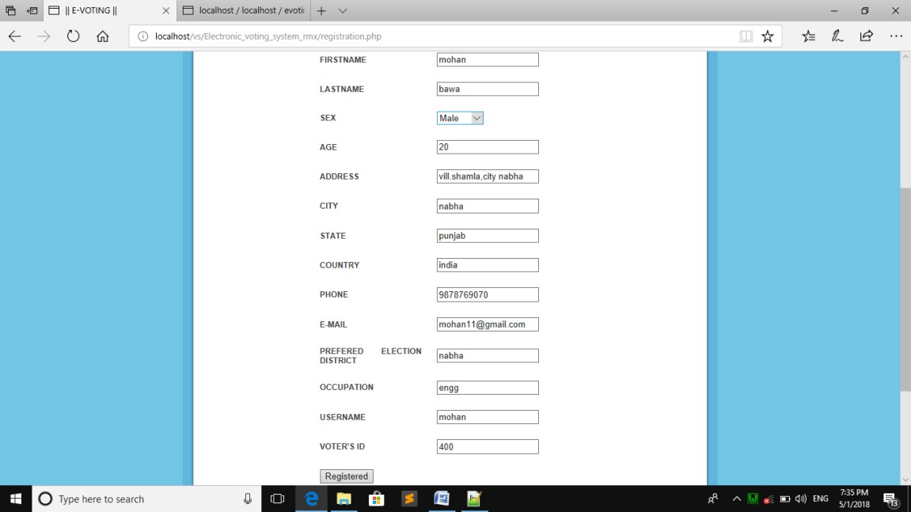Home page of the E-Voting System where admin can login ,user can view the information about E-voting,Voter can register through this page.

Snapshot 2:”Voter registration page”

This is is a voter registration page through which voter can register to cast the vote.

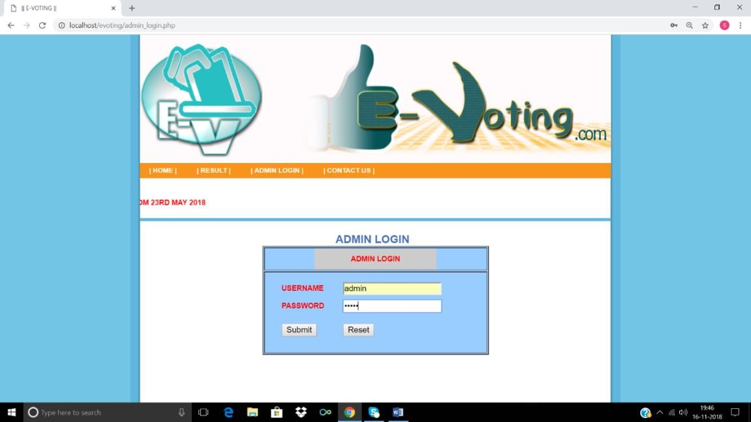

Snapshot 3:”Admin login”

This is admin login page,where user can login.

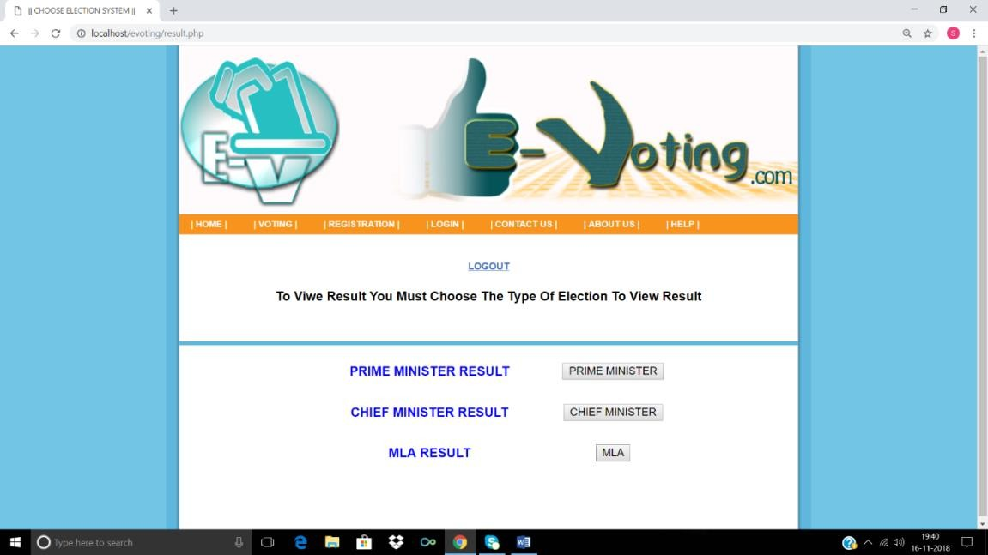

Snapshot 4:”Result page”

The above snapshot is result page,where result can be viewed

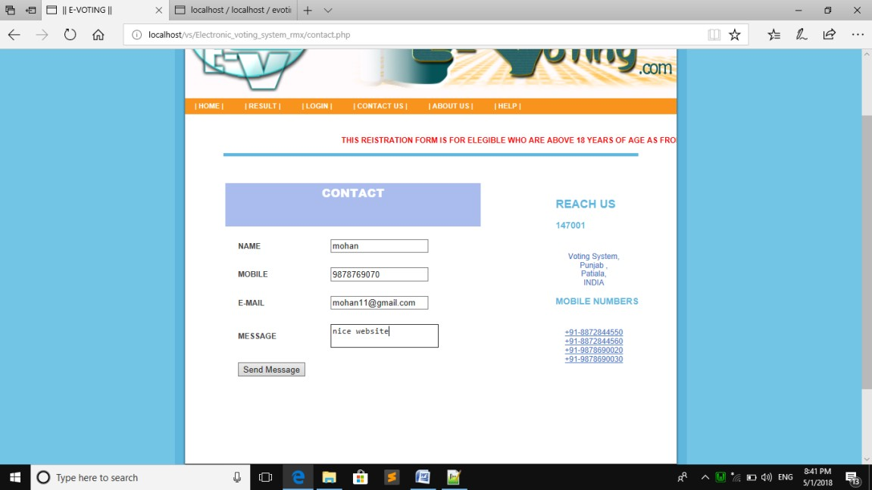 Snapshot 5:”Contact page”

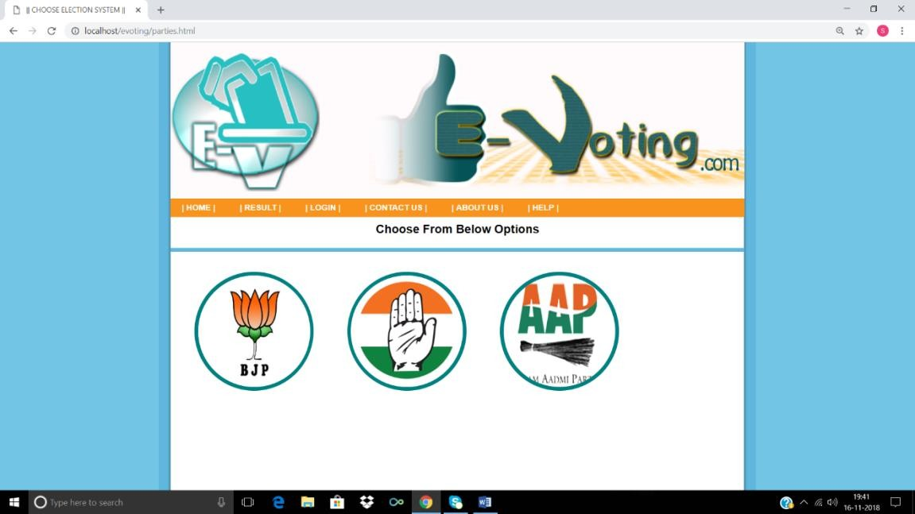The above snapshot is contact page. Here user can contact if they have any queries.

Snapshot 6:”Parties information page”

This is parties information page where user can view the information about different

Parties candidates.

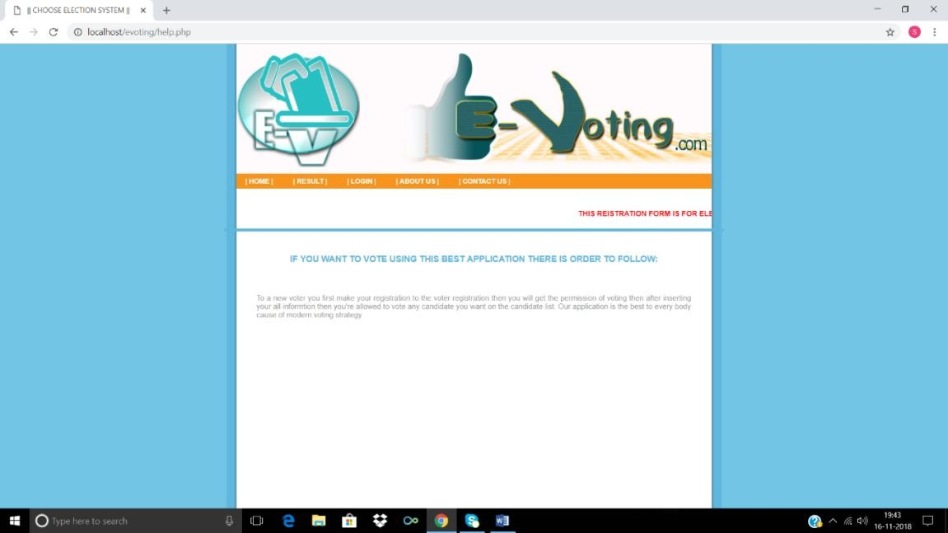 Snapshot 7:”Help page”

The above snapshot is Help Page,here user can go for taking help if in case of any problem.

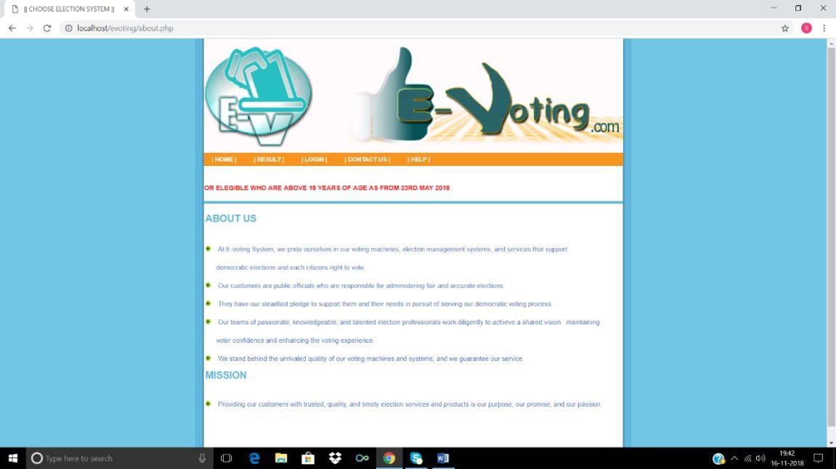

Snapshot 8:”About Page”

The above snapshot is about page,where user can view about e-voting conductor.

**CONCLUSION AND FUTURE ENHANCEMENT**

To conclude the description about the project: The project is developed using Brackets, and PhpMyAdmin based on the requirement specification of the user and the analysis of the existing system, with flexibility for future enhancement.

The expanded functionality of today’s software require an appropriate approach towards software development. Presently we designed our Placement management system to be very User Friendly. Many features are enhanced to the present Placement Cell. With this Placement management system most of the placement officers time is saved. The features of the system can be further enhanced in many ways. The documentation that has enclosed can enable even a person with minimum knowledge to understand it well.

Future enhancement is very important for each project because it includes latest features in the System. It creates strong relationship with customer according to their feedback or choices. Finally, The features provided by the placement management system makes it one of an interactive platform for Placements.

**REFERENCES**

1)Fundamentals of PHP by W3Schools

2)Fundamentals of HTTP and CSS by w3Schools

3) Fundamentals of Database systems by Elmasri and Navathe

4) websites

* https://en.wikipedia.org/wiki/Java_servlet
* [https://www.javatpoint.com](https://www.javatpoint.com/)
* <https://www.w3schools.com>
* https://javabrains.io
* <http://www.c-sharpcorner.com/UploadFile/fd0172/how-to-create-connection-of-java-with-oracle10g-database>